7PAM2000 Applied Data Science 1

Assignment 1: Visualisation

Muhammad Awais: 22027179

Introduction:

The World Bank climate change dataset is a comprehensive collection of data that provides valuable insights into the various aspects of climate change across countries and regions around the world. This dataset encompasses a wide range of indicators, including greenhouse gas emissions, energy consumption, renewable energy capacity, forest area, temperature changes, sea level rise, and more. It offers a rich resource for researchers, policymakers, and stakeholders to analyze and monitor the impacts of climate change, track progress in mitigation and adaptation efforts, and make informed decisions to address the challenges posed by climate change. The World Bank climate change dataset serves as a crucial tool in understanding the global trends, patterns, and dynamics of climate change, facilitating evidence-based actions and policies towards building a more sustainable and resilient future.

1. Line Plot:

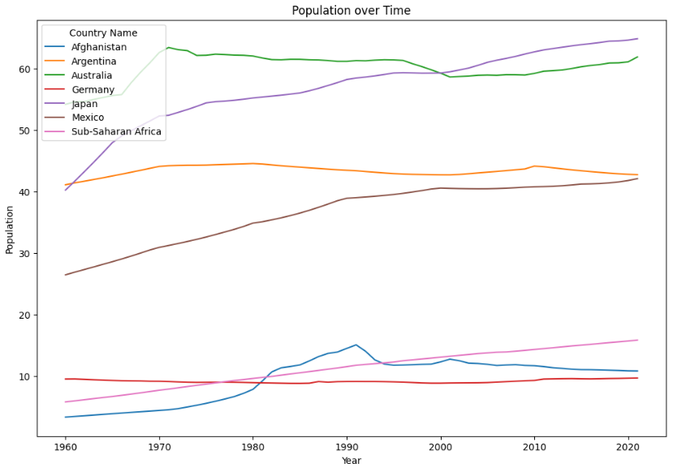

Figure 1: urbanization and concentration of population

This indicator provides insights into the level of urbanization and concentration of population in large cities within a country. This line plot displays a comparison of seven countries such as Afghanistan, Argentina, Australia, Germany, Japan, Mexico, and Sub-Saharan Africa with the years ranging from 1960 till 2021. As we can see in the graph, only Sub-Saharan Africa and Japan have made significant improvements. For other countries the indicator is either uniform or with a minimal change.

1. Other two Visualizations:
2. Pie Chart

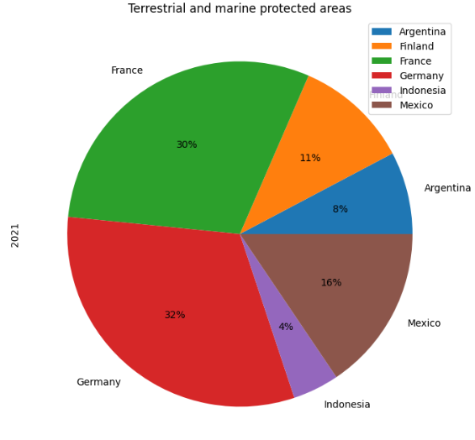

Figure 2: Terrestrial and marine protected areas (% of total territorial area

This pie chart represents the distribution of "Terrestrial and marine protected areas (% of total territorial area)" across different countries. This indicator measures the percentage of a country's total territorial area that is designated as protected areas, including both terrestrial (land-based) and marine (oceanic) environments. The largest area which is 32% is covered by Germany, followed by France with 30%. The lowest area covered by Indonesia is 4%.

1. Grouped Bar Chart

To create a grouped bar chart for "School enrolment, primary and secondary (gross), gender parity index (GPI)," The climate change dataset contains the relevant data for different regions or countries.

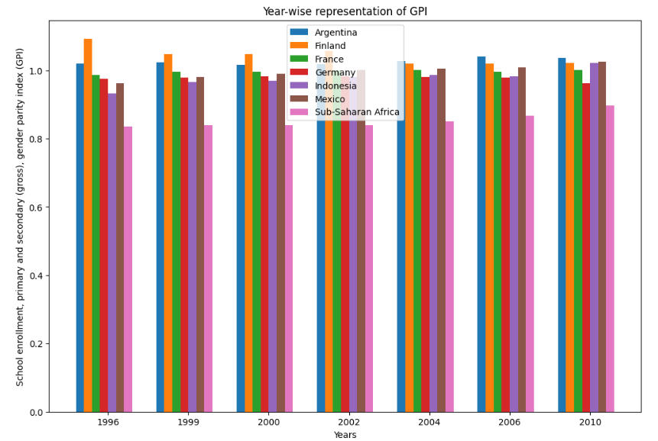

Figure 3: School enrolment, primary and secondary (gross), gender parity index (GPI)

In this grouped, we read the dataframe that contains the relevant data, including columns for 'Country Name', and years such as '1996', '1999', '2000', '2002', ‘2004’, ‘2006’ and '2008'. We filter the data to include only the rows with the desired indicator, 'School enrolment, primary and secondary (gross), gender parity index (GPI)'. The graph shows a comparison of various countries such as Argentina, France, Germany, Finland, Indonesia, Mexico, and Sub-Saharan Africa. For Sub-Saharan Africa the index has been the same throughout the years. The highest value of this index was reported in 1996 for Finland but that decreased gradually until 2010. Germany and France have also been consistent during the mentioned years.